Photographic Essay: Water Scarcity among African Communities

**1.The daily struggles for water**

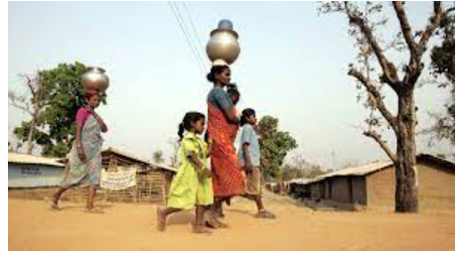

*Women and children frequently walk for long distances to fetch water from a distant source due to scarcity of water supply points.*

**2.Contaminated water sources**

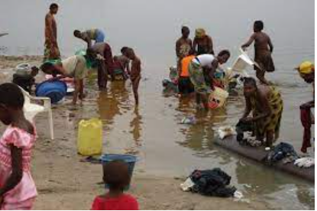

*African community members engage in collecting water from a contaminated source which contributes to various health issues.*

**3.Impact of Contaminated water on health**

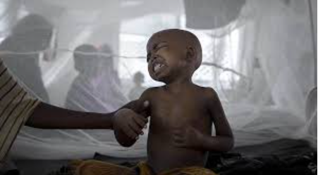

*Children suffering from waterborne diseases after taking contaminated water due to lack of access to clean water.*

**4.Innovative solutions towards scarcity of water**

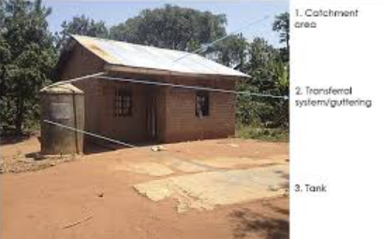

*Community-driven initiatives such as rainwater harvesting and well construction helping alleviate water scarcity.*

**5.Creating awareness towards water solution**

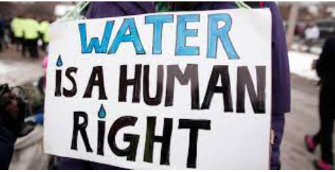

*Local activists raising awareness and advocating for clean water access as a basic human right to the African community members.*